Custom Training

Day 15

**Python Pandas**

Pandas: Python library.

Dataframe: Holds the data in rows and columns form. Combination of more than one series(one column is called series).

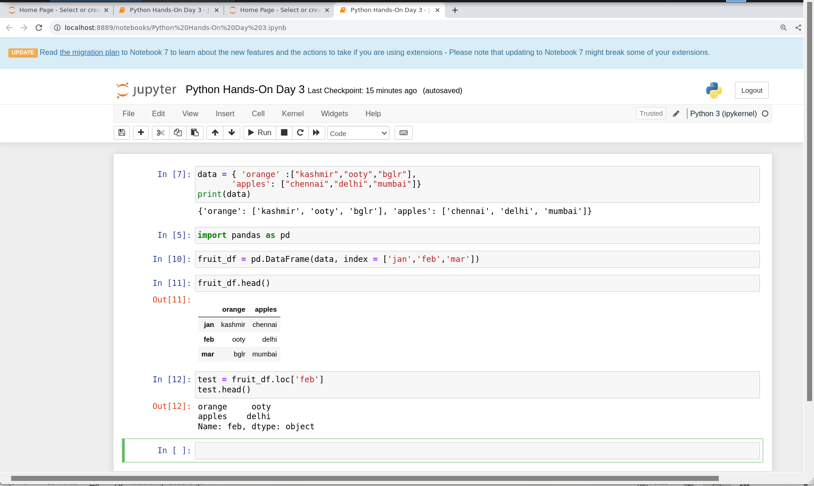

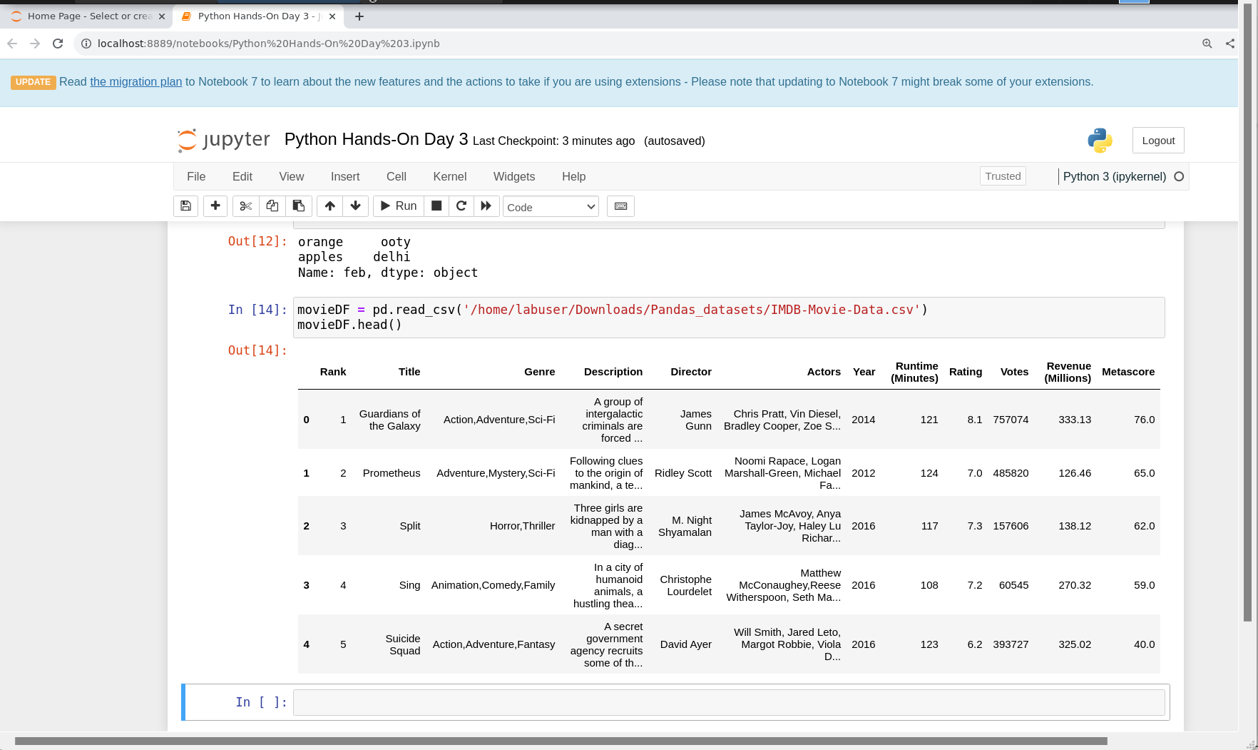

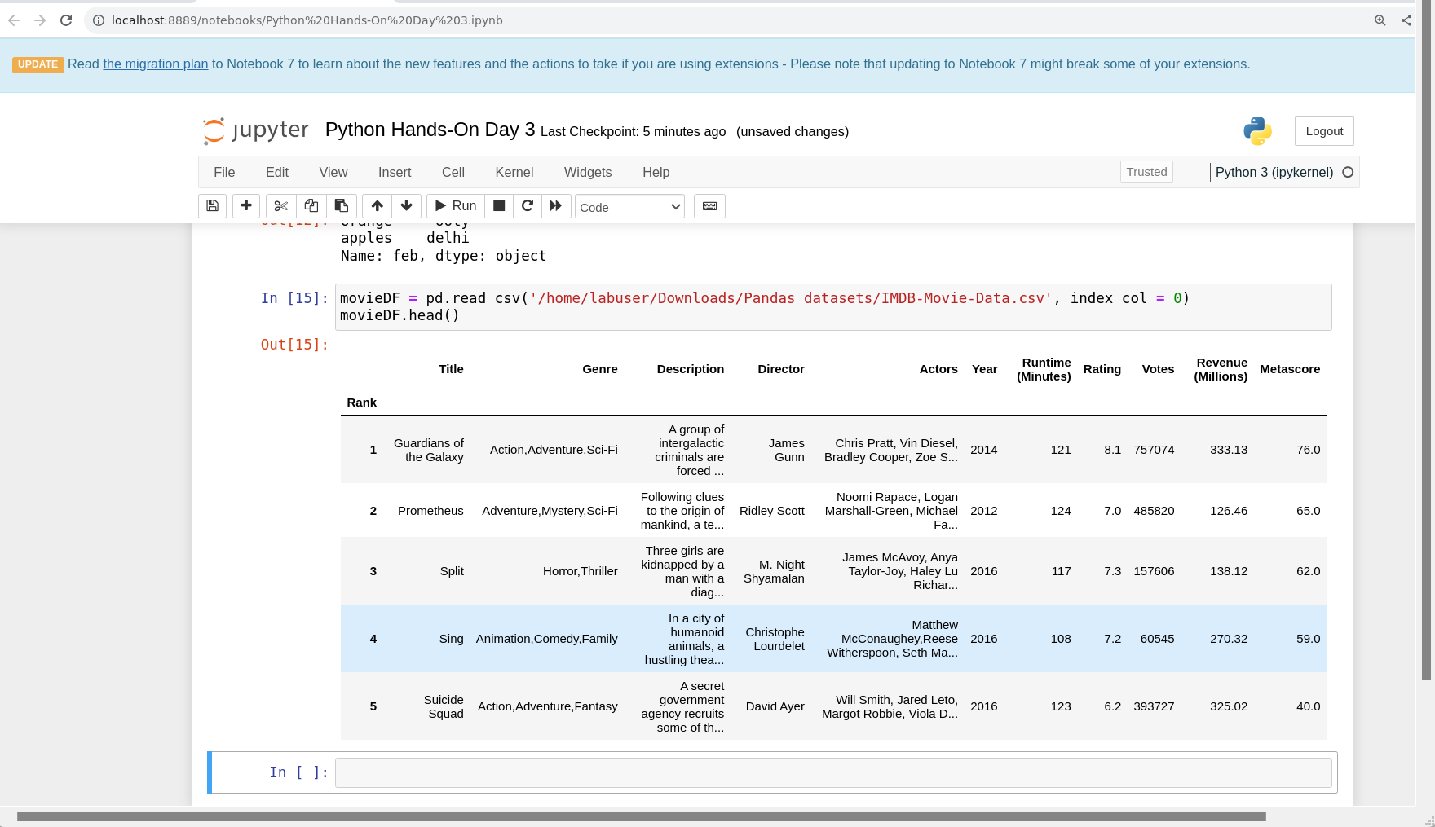

Drop_duplicates : Removes duplicate rows from the dataframe.

Shape: Shows the number of rows and columns of the dataframe.

Append(): Append two dataframes.

Info(): Gives the information about the dataframe just like describe command in sql.

Columns: Shows the column names of the dataframe.

Inplace Attribute: If we want to do the transformation in the same dataframe.

Rename(): Rename the column names of the dataframe.

By applying the list comprehension method we can convert the column names to upper/lower case:

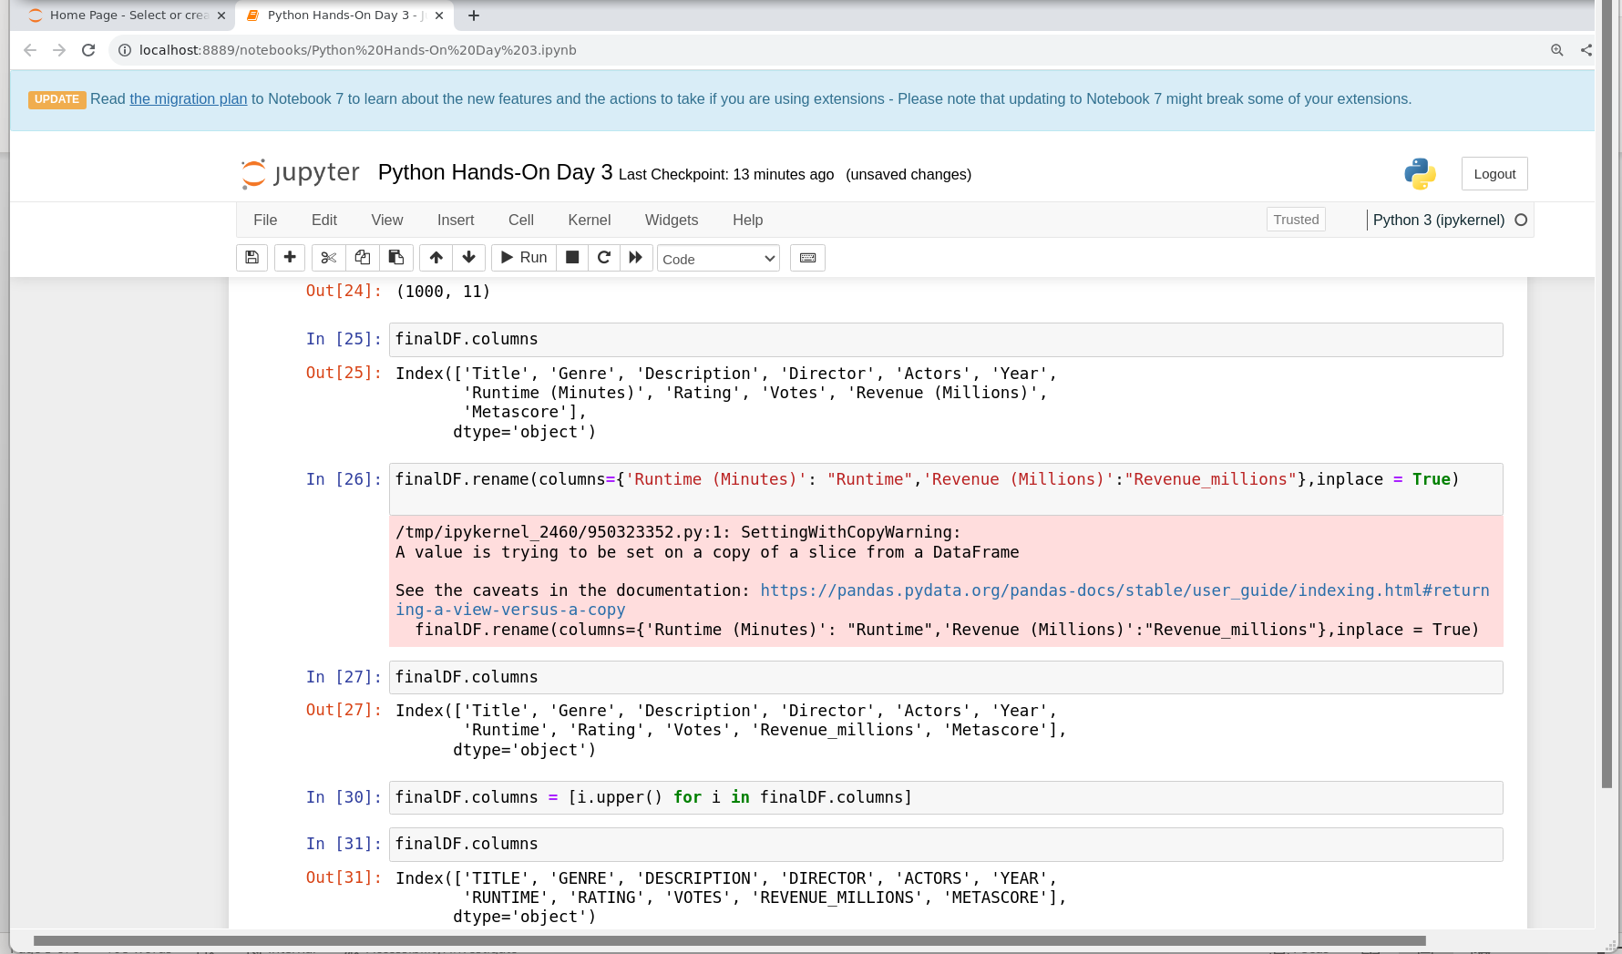

When you convert one column as index column then that column will not be listed in the columns list.

Dropna(): To drop null rows.

Axis attribute: Used with dropna to drop the columns having null values.

Isnull(): To show where in the rows null values are present.

Sum(): Used with isnull() method to show the count of null values in each column.

Imputation: Do any activity to overcome the null values issue.

Fillna(): To replace null values with some default value.

Mean(): To calculate the mean.

Describe(): To get more information of the table like mean, count, etc.

Value_counts(): To show the records in groups by unique values of the column.

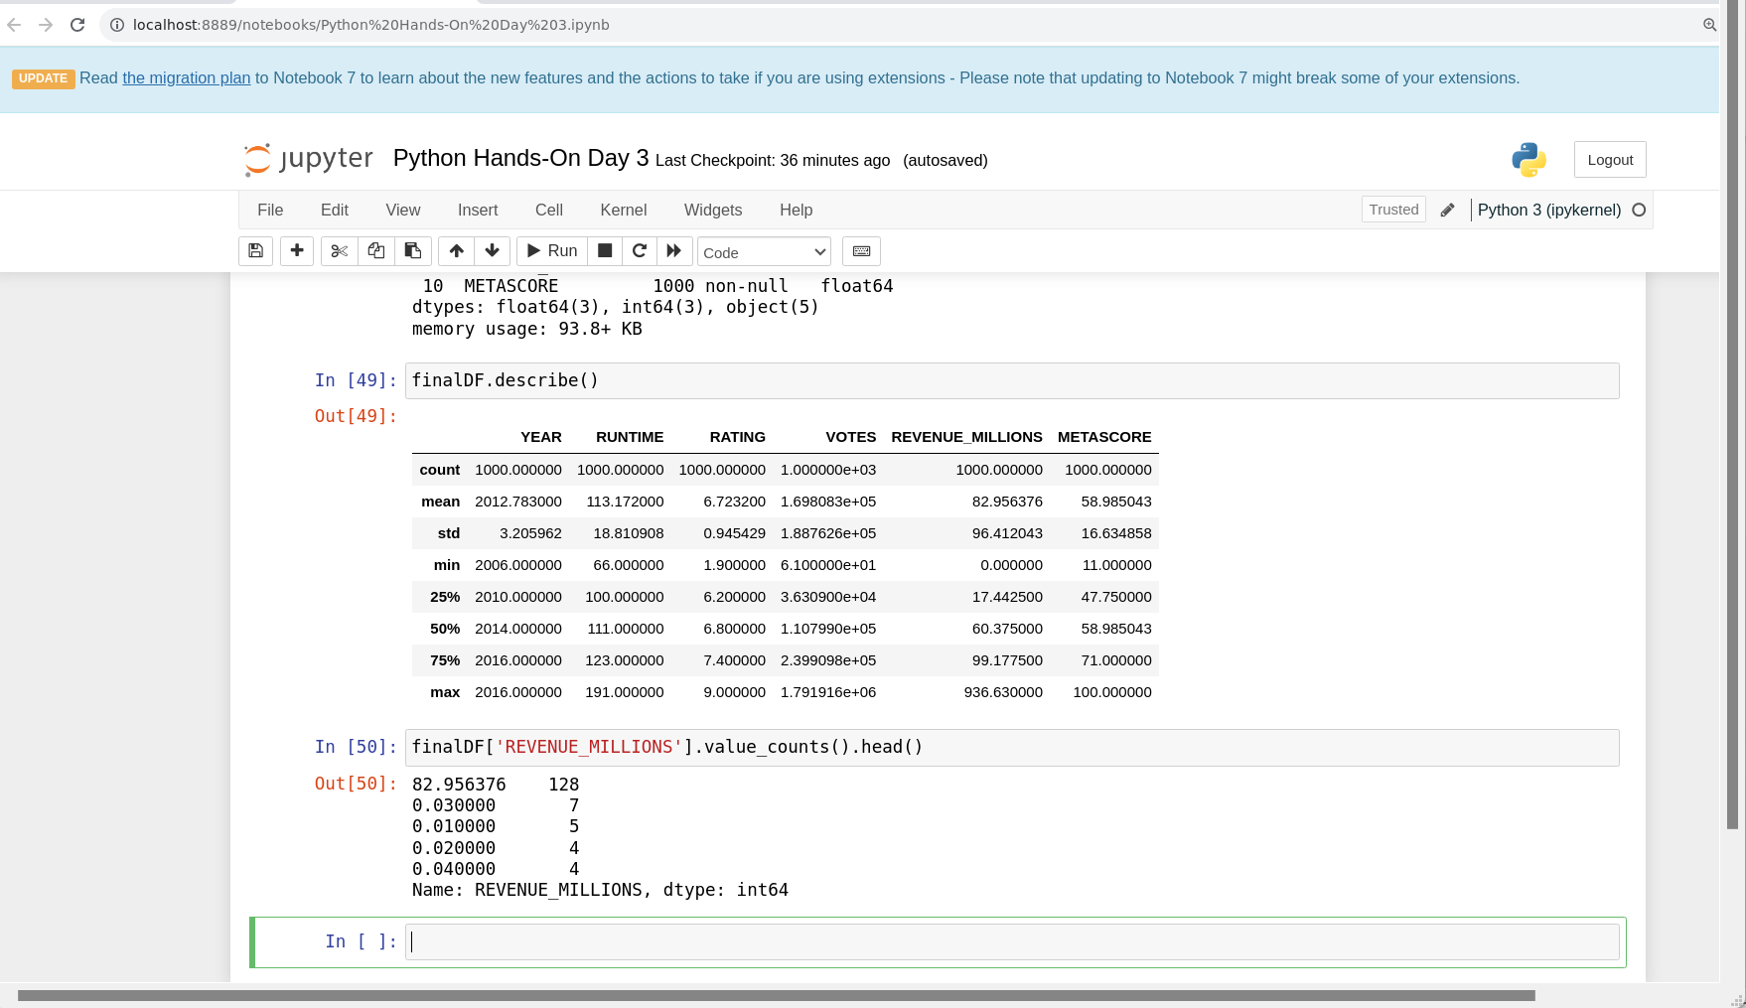

Iloc: To get specific row index range.

Conditional Select: To fetch rows based on some conditions.

Applying function to create new column in the dataframe:

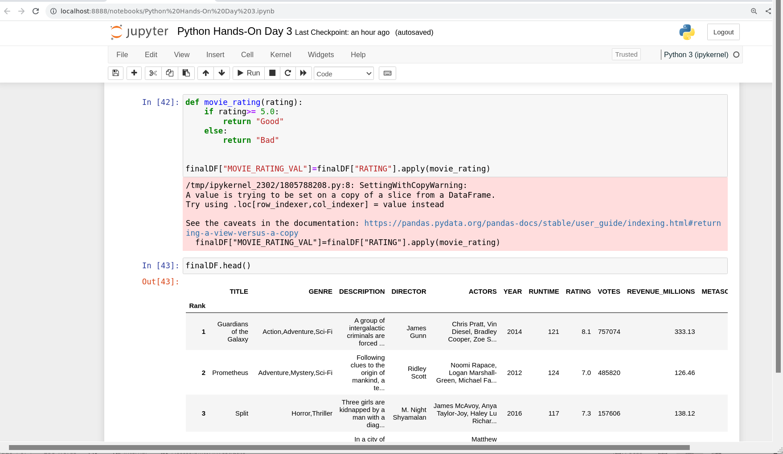

Matplotlib: Used to plot graphs.

